Imaging the Sun

Satellite I have studied for this purpose was **FalconSat 7**.

|  |  |
| --- | --- |
| Type | 3U CubeSat |
| Size | 30 cm x 10 cm x 10 cm |
| Mass | 5 kg |
| Orbit | Sun-synchronous orbit | |
| Altitude | 720 km | |
| Inclination | 97.5 degree | |
| Mass of payload | 1.7 kg | |
| Mass of Photon Sieve | 1.75 grams | |

The payload is Peregrine: the world's first spaceborne membrane telescope. FalconSat-7 telescope technologies could enable affordable, very large space-based solar observatories with imaging resolutions sufficient to understand the small-scale spatial dynamical structures of the sun's chromosphere that contribute to the formation of solar flares and CMEs (Coronal Mass Ejections).

Its preliminary designs have a 0.3m aperture deployed from a 6-12U satellite. Such a telescope would be capable of providing sub-meter resolution of ground or space-based objects depending on the orbital characteristics. Half of the 3U CubeSat volume is devoted to bus avionics. Within the remaining volume the project has configured a payload which consists of

1. 20cm polyimide membrane photon sieve

2. Support structure consisting of an aluminum hexapod and polyimide lanyards ( deployment structure )

3. Secondary optics (including secondary lenses, baffles, filter and fold mirrors) , focusing stage and CCD “science” camera

4. Imaging control electronics (storage, focusing control, image manipulation etc)

5. Secondary “inspection” camera

The primary optic is a 0.2 m photon sieve – a diffractive element, consisting of billions of tiny holes in an otherwise opaque polymer sheet. Once in space the supporting pantograph structure is deployed to pulling the membrane flat under tension. The telescope will then be steered towards the Sun to gather images at H-alpha band (656.4 nm) for transmission to the ground.

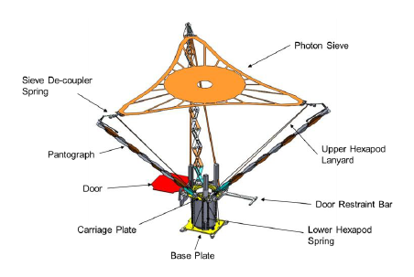

In order to point at the Sun, the spacecraft will be 3-axis controlled. With a 0.5 degree pointing accuracy assumed for the CubeSat, analysis indicates that the sun will be in the FOV (Field of View) of the telescope system 56% of the time. There are several commercial solutions for providing this level of pointing accuracy; for example Maryland Aerospace's MAI-400 ADCS (Attitude Determination and Control Subsystem) unit.

The spacecraft will Sun-soak for most of the orbit that is not in eclipse. Requirements imposed due to this

1. slewing from a Sun-soak attitude to a Sun-imaging attitude(done each orbit in order to collect one image per revolution)
2. subsequent relaxation of thermal gradient induced
3. ADCS maneuvering vibrations
4. Slewing as necessary will be done to download images to the ground. Each image will take 6 minutes to download

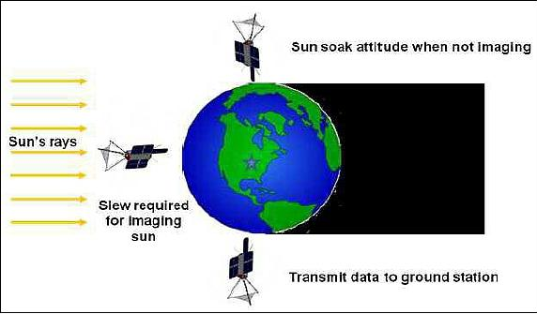

**Deployment mechanism**

The payload deployment structure consists of three spring-load pantographs stowed under compression and the catenary shaped membrane gently folded inside the center. Once in orbit, the hinged end panel opens by the release of a burn wire and the pantographs deploy automatically. The membrane is pulled to the required flatness by a 0.5 N radial tension provided by the pantographs and upper lanyards that form a tensioned upper hexapod. The positioning of the photon sieve depends critically on the lengths of these lanyards which form a determinate system. The photon sieve is de-coupled from the pantographs by springs. In order for the pantographs to deploy without interference from the bus structure, they are mounted to a carriage plate that moves the entire deployment system to the end of the bus. The carriage plate positioning is also critical for optical positioning of the photon sieve and is held in place by a second tensioned lower hexapod. The tension for the lower hexapod is provided by springs. In the first stage of the deployment system, the assembly moves linearly out of the bus. The second stage is held in place using three sequencing bars. Once the bottom of the assembly clears the top of the bus, the sequencing bars all disengage and allow the second stage of the deployment. During the second stage of the deployment 3 precision pantograph arms extend to their final position, putting tension on the photon sieve and ensuring high-quality imagery. The photon sieve is configured to focus light down the center of the satellite to secondary optics (lenses, filters and fold mirrors) and onto a CCD camera. Some focusing is made possible by the inclusion of an electronically controlled stage holding the secondary lenses.

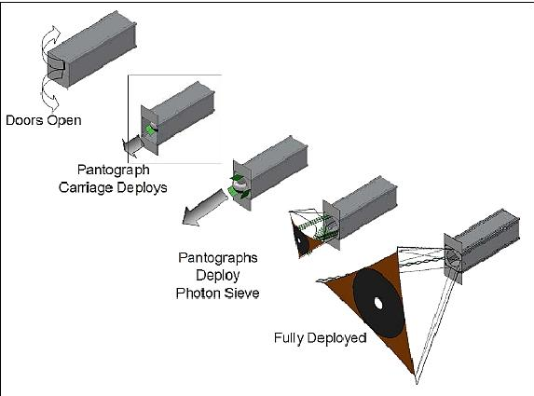

Image of pantograph

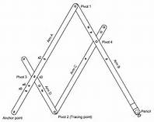

Pantograph arms extend 43 cm from the satellite body.

**PHOTON SIEVES**

Diffractive optical elements (DOEs) rely on extremely small features to focus light by direct modulation of the amplitude and/or phase of the incident wavefront. One such DOE is the Fresnel Zone Plate (FZP). A FZP of focal length *f* can be constructed by locating *n* transparent circular zones on an otherwise opaque substrate at radial distances *rn* given by:



A slight modification of the FZP is the photon sieve. It is made by breaking the concentric rings up into individual holes of the same diameter as the underlying zones. They are constructed on aluminum-coated polyimide films that are strong, rollable, and light. These membrane materials have demonstrated near-zero CTE (Coefficient of Thermal Expansion), which is crucial for avoiding issues with pattern distortion in the changing thermal environment experienced in orbit. To create an image, 2.5 billion depressions are photo-lithographically etched on the surface forming images in essentially the same manner as a Fresnel lens. The size and position of each hole is configured such that transmitted light is diffracted to a focal plane array within the CubeSat.

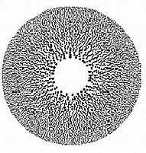

Photon sieve has 50% fill factor, 30% focusing efficiency

PS consists of holes of diameter rn located at the corresponding radial distance rn. The holes can be distributed regularly or randomly in angle about the zone. It has since been found that the diameter of the holes can be increased to an optimum value of 1.514 times the underlying zone width, greatly relaxing the fabrication constraints.

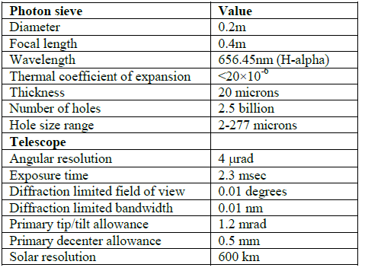

The photon sieve has some advantages over the FZP including

1. a simpler design and construction, apodization control and (under most circumstances) improved resolution and contrast.
2. it is possible to construct large photon sieves with millions of holes giving diffraction limited imaging suitable for large telescopes.

Why photon sieve in place of conventional reflection type telescope?

1. Issue of packing large monolithic structures into limited launch vehicle volumes. Photon Sieve is made on a flexible membrane that can be folded. This allows for deployed apertures with a diameter larger than the satellite bus.
2. PS is extremely lightweight. With the use of polyimide membranes the project is aiming at areal densities of 0.25 kg/m2 — a game-changing 3 orders of magnitude improvement above the current state-of-the-art.
3. This comes along with similar savings in fabrication a materials cost.because the cost of fabricating surfaces to the high degree of precision required results in telescope costs scaling roughly as the diameter to the power of 1.75 (D1.75) and PS (Photon Sieve) surface requirement is around two orders of magnitude less stringent than that of traditional optical surfaces.(for eg. Sieve must be flat within about 10 times the wavelength of light while reflective or refractive type telescope must maintain a surface quality of about 1/10th of wavelength)

**disadv**-the deployment of the photon sieve must be exceptionally precise for the optical system to produce high quality imagery

challenge – construction of photon sieves on polyimide membranes (relief here is that DOEs do not require a perfectly flat surface to give perfect imaging)

The one significant trade-off in using DOEs is a reduced bandwidth. Due to dispersion, the focal length depends heavily on the wavelength of light chosen. As such, zone plates are typically limited to narrowband focusing or imaging applications. Allowing for depth of focus considerations, we can find that the bandwidth for diffraction limited imaging is given by:



it is possible to improve the bandwidth of the overall telescope by including a secondary HOE into the design, but it is difficult to extend this beyond a few tens of nanometers to permit true multispectral imaging. As a result, the use of diffractive primaries may be restricted to high resolution, greyscale imaging only. For Peregrine (D = 0.2 m, f = 0.4 m, wavelength= 656.3 nm) the bandwidth is only 8.6 picometer (pm), but for Solar observations, there will be sufficient photon flux to permit imaging.

Making the PS aperture size larger obviously provides better diffraction limited imaging. On the other hand, making the photon sieve larger decreases the optical bandwidth

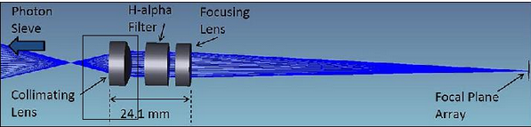

The secondary optics of the photon sieve telescope (see Figure) collimate the focused beam from the photon sieve for transmission through a narrowband Andover filter (1.5 A FWHM, 35% peak transmission) and change the effective f-number of the system to f/10. The narrowband hydrogen alpha filter eliminates the majority of non-focused light at the FPA (Focal Plane Array) of the camera. The collimated beam is approximately 10 mm in diameter, and the final focal distance from the second lens to the camera focal plane is about 100 mm. The three fold mirrors after the final lens are not shown.

The optical system of the FalconSAT-7 peregrine payload consists of eight elements. A flexible membrane primary focuses light at 40 cm. A 12 mm achromatic doublet with 15 mm focal length is used to collimate the light coming from the primary followed by a Fabry Perot bandpass filter with a 0.1 nm bandwidth centered at 656.45 nm to eliminate unwanted wavelengths. A second achromatic doublet with a 100 mm focal length focuses the image on the camera. Three fold mirrors are used to direct this beam to an 8 bit monochrome CMOS camera.

Thermal modeling has shown that the membrane will experience thermal cycling in the range of 250-350K. This will result in dimensional changes in the membrane that cause changes in the imaging characteristics. It was initially planned on using Novastrat, a near-zero CTE polyimide, manufactured by Nexolve of Huntsville, AL., as the substrate material because this material has been space-tested and can be chemically "tuned" to just about any desired CTE. Also the project has to ensure a high degree of thickness uniformity(25 micrometer) as the light will be transmitted through the substrate. Nexolve has demonstrated control to the thickness constraints necessary for the needs of the project. But mechanical tests have shown this to be too brittle to survive our deployment process.So, now Kapton is planned to be used. It has greater elastic strength but with an increased CTE which will restrict imaging to a 10 minute window in each orbit

Constraint on electronics - The Peregrine electronics must provide C&C (Command and Control) of the payload, as well as data handling. The C&C requirements include the operation of the main CCD camera and inspection camera, FPGA (Field Programmable Gate Array) control, and movement and reading of the translation (focusing) stage. Figure, given below, is a block diagram of the payload electronics.

